KEELAN DUDDY – G00385886

Keelan duddy

Contents

Lab 1 & 2: 3

Table: 3

3

CPU 4

Motherboard 5

RAM 6

SSD 7

Graphics card 9

Power Supply 10

Case 11

Keyboard 13

Mouse 14

Monitor 15

Lab 3: 17

Linux intro: 17

Lab 4 linux commands 18

Password: 18

Date: 18

Hostname: 18

Arch: 18

Uname -a: 18

Dmesg | more: 19

Uptime: 20

Whoami: 20

Who: 20

Last: 21

Finger: 22

W: 22

Top: 23

ECHO $SHELL: 24

Man ls: 25

Man who: 25

Clear: 26

Cal 2000: 26

Cal 9 1752: 27

Yes please: 28

Time sleep 5: 29

Tetris-bsd: 29

History: 30

Lab 5 linux vm & permissions: 32

Virtual machine: 32

Permissions: 32

Lab 1 & 2:

## Table:

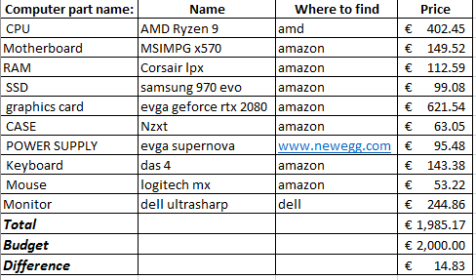

four different vendors: Amazon, amd, newegg, and dell.

## 

## CPU

Name: CPU = AMD Ryzen 9 3900X 12-core, 24-Thread Unlocked Desktop Processor with Wraith Prism LED Cooler

Link: <https://www.amd.com/en/products/cpu/amd-ryzen-9-3900x>

Price: 402.45



Description: Having a very fast CPU with a lot of cores and threads will help edit 4k footage to be a lot smoother and faster.

Specs:  **# of CPU Cores** 12 **# of Threads** 24 **Base Clock** 3.8GHz **Max Boost Clock** Up to 4.6GHz **Total L1 Cache** 768KB **Total L2 Cache** 6MB **Total L3 Cache** 64MB **Unlocked**Yes **CMOS** TSMC 7nm FinFET **Package** AM4 **PCI Express® Version** PCIe 4.0 x16 **Thermal Solution (PIB)** Wraith Prism with RGB LED **Thermal Solution (MPK)** Wraith PRISM **Default TDP / TDP** 105W **Max Temps** 95°C

## Motherboard

Name: MSI MPG X570 Gaming Plus Motherboard

Link: <https://www.amazon.com/MSI-X570-Gaming-Plus-Motherboard/dp/B07T5QDRFX>

Price: 149.52

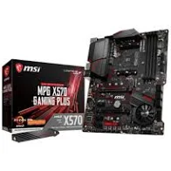

Description: This motherboard fits all the features you need and is able to be upgraded if needed.

Spec:

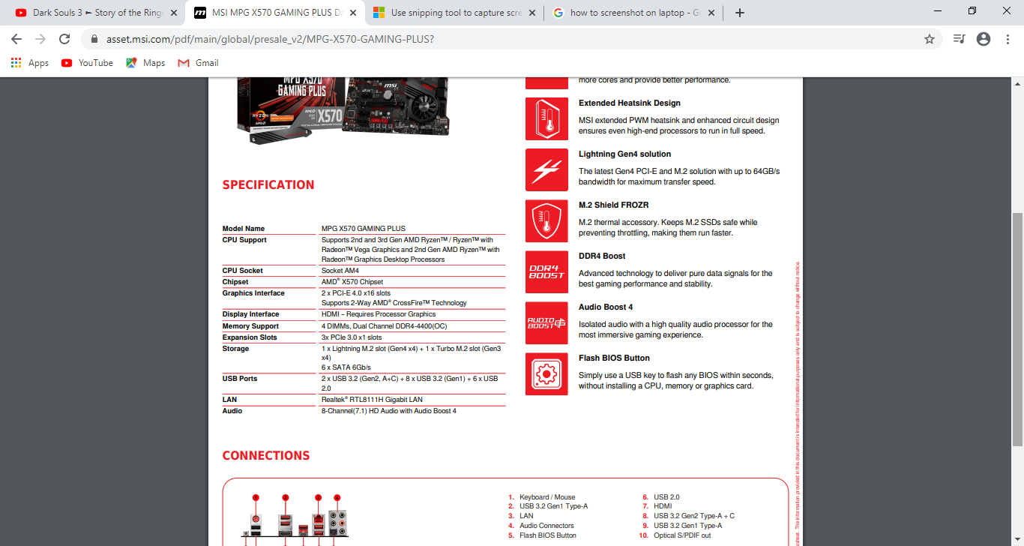

## RAM

Name: Corsair LPX 32GB (2x16GB) 3200MHz C16 DDR4 DRAM Memory Kit, Black (CMK32GX4M2B3200C16)

Link: <https://www.amazon.com/Corsair-2x16GB-3200MHz-Memory-CMK32GX4M2B3200C16/dp/B016ORTNI2>

Price: 112.59

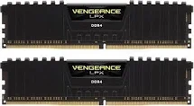

Description:

The RAM can handle editing 4k footage.

Spec:

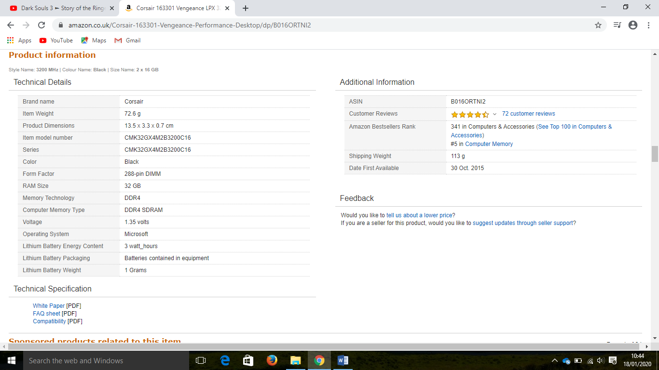

## SSD

Name: Samsung 970 evo plus ssd 500gb

Link: <https://www.amazon.com/Samsung-970-EVO-Plus-MZ-V7S500B/dp/B07M7Q21N7>

Price: 99.08

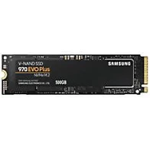

Description: use this SSD to store your operating systems and programs for fast video editing. Not the video files.

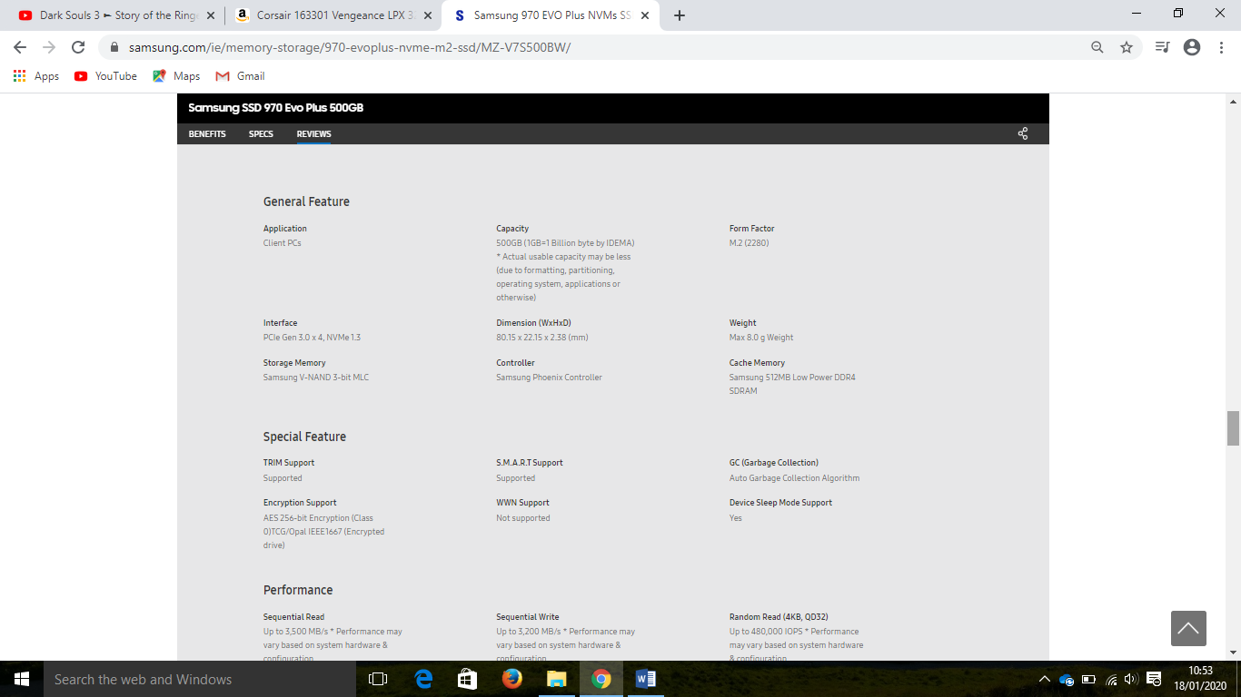Spec:

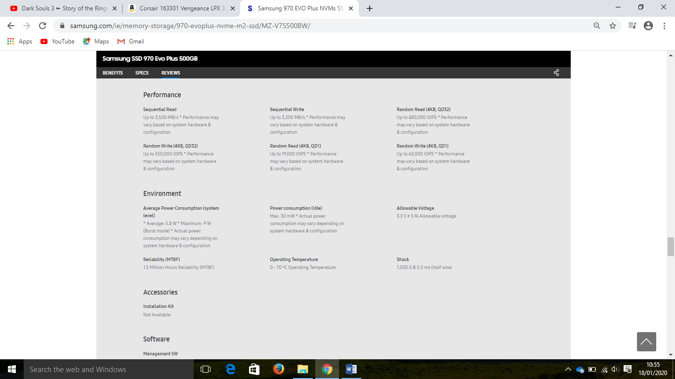

## Graphics card

Name: EVGA GeForce RTX 2080 Super Black Gaming, 08G-P4-3081-KR, 8GB GDDR6

Link: <https://www.evga.com/products/product.aspx?pn=08G-P4-3081-KR>

Price: 621.54

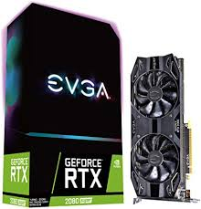

Description: This graphics card can handle using premiere pro when using a lot of graphic effects. Overall it increases performance.

Spec:

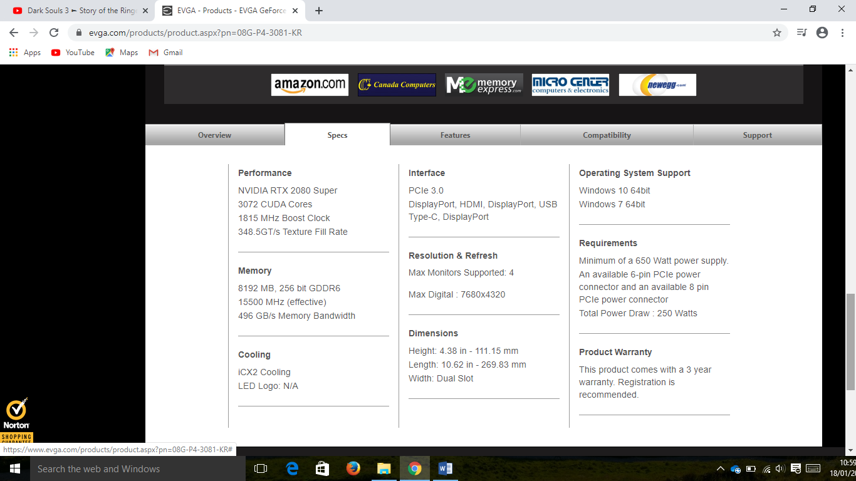

## Power Supply

Name: EVGA SuperNOVA 750 g3 power supply

Link: <https://www.newegg.com/evga-g3-series-220-g3-0550-y1-550w/p/N82E16817438095>

Price: 95.48

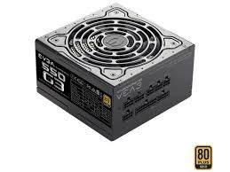

Description: This will give you enough power to run all the other components in the PC.

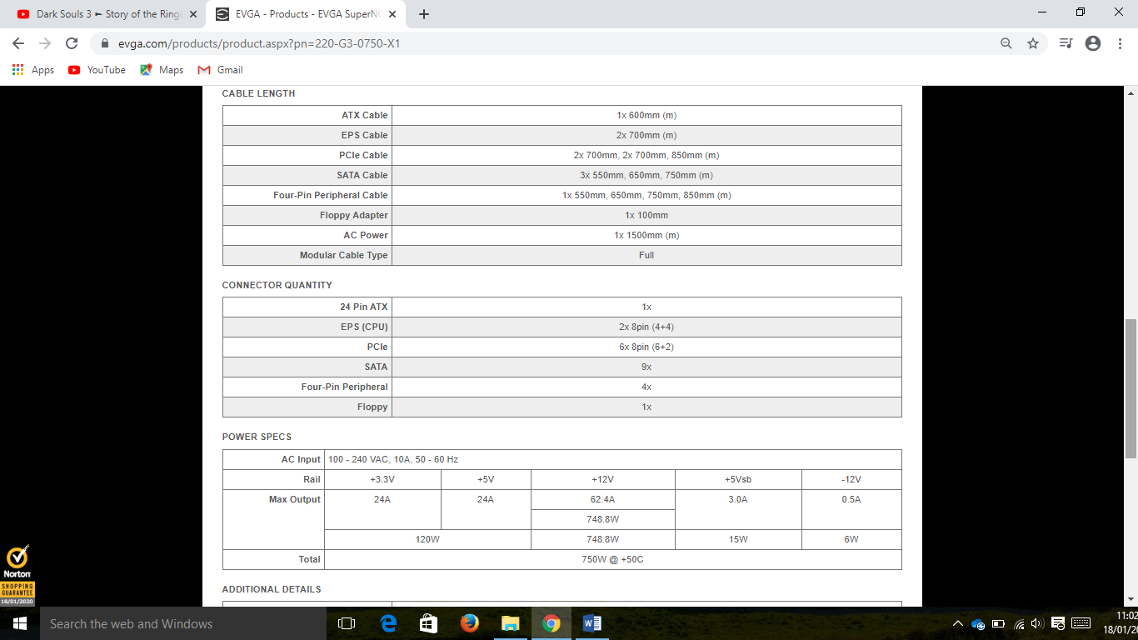Spec:

## Case

Name: NZXT H510 - CA-H510B-B1 - Compact ATX Mid-Tower PC Gaming Case - Front I/O USB Type-C Port - Tempered Glass Side Panel - Cable Management System - Water-Cooling Ready – Black

Link: <https://www.amazon.com/NZXT-H510-Management-Water-Cooling-Construction/dp/B07TD9C5HS>

Price: 63.05

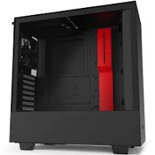

Description: Cheap great valued case that can fit all components, it also has very good air flow for its price.

Specs:

* Dimensions: W: 210mm H: 435mm D: 428mm (without feet) W: 210mm H: 460mm D: 428mm (with feet)
* Material(s): SGCC Steel, Tempered Glass
* Weight 6.6 kg
* Motherboard Support: Mini-ITX, MicroATX, and ATX
* Front I/O Ports: 1x USB 3.1 Gen 2 Type-C

1x USB 3.1 Gen 1 Type-A

1x Headset audio Jack

Front I/O internal header

1x USB 3.1 Gen 2 Internal Header

1x USB 3.1 Gen 1 Internal Header

1x HD Audio Header

* Filters: All Air Intakes
* Included Accessories: Installation screws, 10x Cable ties, 1x Headset Audio Jack splitter (4 pole to 3 pole)
* Drive Bays: 2.5”: 2+1, 3.5”: 2+1
* Expansion Slots: 7
* Radiator Support: Front: 2x 140 or 2x 120mm with Pull, Rear: 1x 120mm
* Fan Support: Front: 2 x 120/ 2 x 140mm, Top: 1x 120mm/ 1x 140mm (1 Aer F120 Case Version included), Rear: 1x 120mm (1 Aer F120 Case Version included)
* Fan Specs: Aer F120 (Case Version), Speed: 1200 ± 200 RPM, Airflow: 50.42 CFM, Noise: 28 dBA, Bearing: Rifle Bearing
* Clearance: Cable Management: 19-23mm

GPU Clearance: Up to 381mm w/o front watercooler installed, up to 325mm with front watercooler installed

CPU Cooler: Up to 165mm

Front Radiator: 60mm

Rear Radiator: 60mm

Reservoir & Pump: Up to 180mm (Along cable bar), Up to 86mm (Along bottom panel)

* Warranty: 2 Years
* Model Number CA-H510B-B1
* EAN 5060301695058
* UPC 815671014757

## Keyboard

Name: Das Keyboard 4 Professional Cherry MX Brown Mechanical Keyboard - Soft Tactile

Link: <https://www.amazon.co.uk/Das-Keyboard-Professional-Brown-Layout/dp/B00JG01QTY>

Price: 143.38

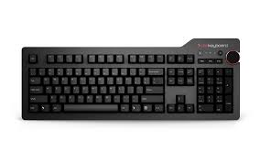

Description: high quality keyboard with volume numb to help easily manage sound while editing 4k footage.

Specs:

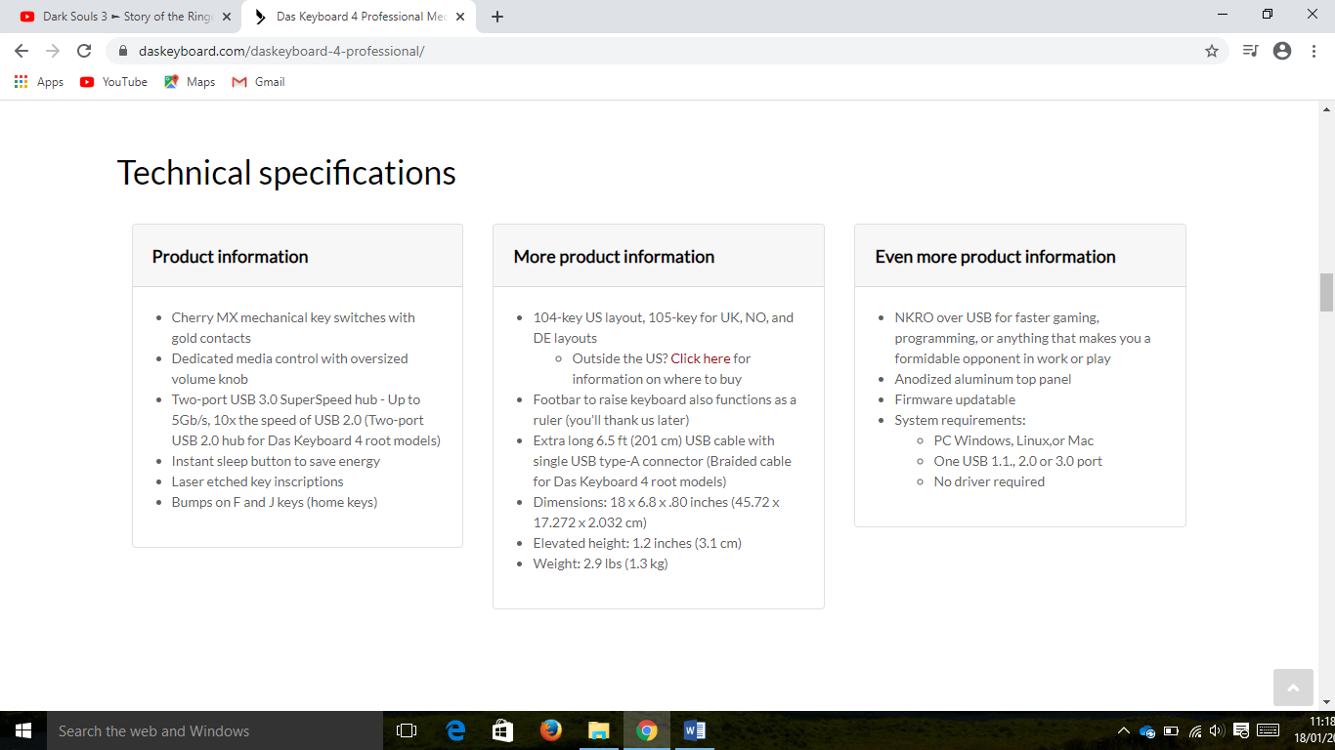

## Mouse

Name: Logitech MX Master Wireless Mouse – High-Precision Sensor, Speed-Adaptive Scroll Wheel, Easy-Switch up to 3 Devices - Meteorite Black

Link: <https://www.amazon.com/Logitech-Master-Wireless-Mouse-High-Precision/dp/B07DHDFW5V>

Price: 53.22

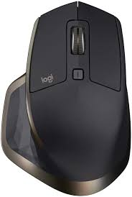

Description: can be used on any surface and is very compatible.

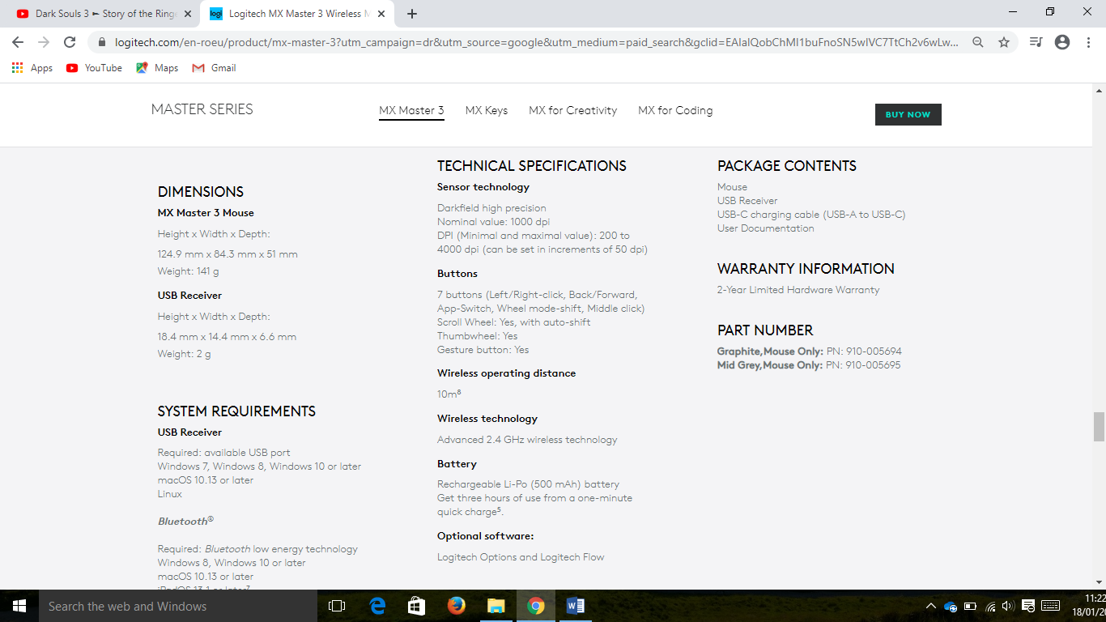Specs:

## Monitor

Name: Dell Computer Ultrasharp U2415 24.0-Inch Screen LED Monitor, Black

Link: <https://www.dell.com/en-ie/shop/dell-ultrasharp-24-monitor-u2415/apd/210-aevc/monitors-monitor-accessories>

Price: 244.86

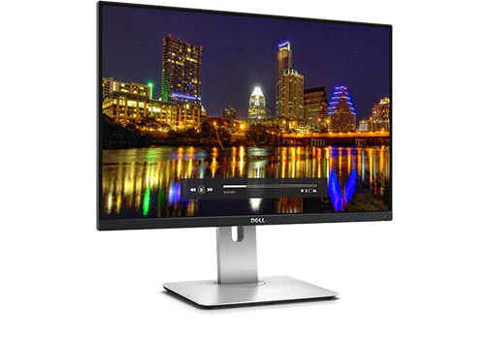

Description: is able to run and show 4k footage for you to edit

Specs: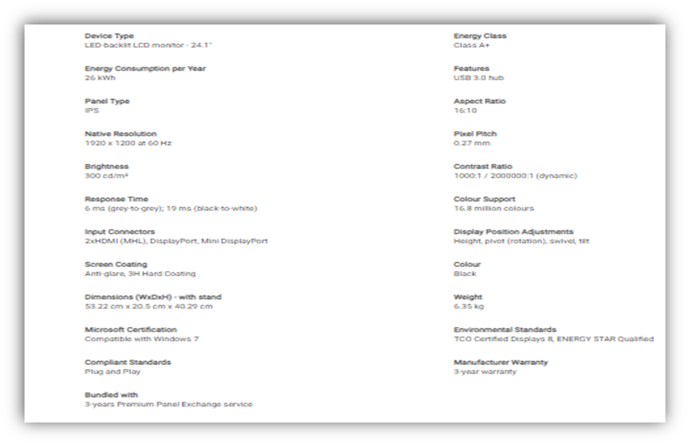



# Lab 3:

## C:\Users\User\OneDrive - GMIT\Computer Technology\keelan.JPGLinux intro:

Ip: [keelanduddy@34.246.176.155](mailto:keelanduddy@34.246.176.155) mongavlin

# Lab 4 linux commands

Password: The passwd command is used to change the password of a user account. A normal user can run passwd to change their own password, and a system administrator (the superuser) can use passwd to change another user's password, or define how that account's password can be used or changed.

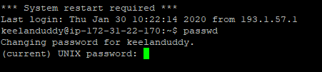

Date: date is used to display the system date and time. date command is also used to set date and time of the system. By default the date command displays the date in the time zone on which unix/linux operating system is configured.



## Hostname:

Brings up the hosts ip address.



## Arch:

arch command is used to print the computer architecture.



## Uname -a:

The uname command reports basic information about a computer's software and hardware.



## Dmesg | more:

dmesg (display message is a comman that prints the message buffer of the kernel. The output of this command typically contains the messages produced by the device drivers.

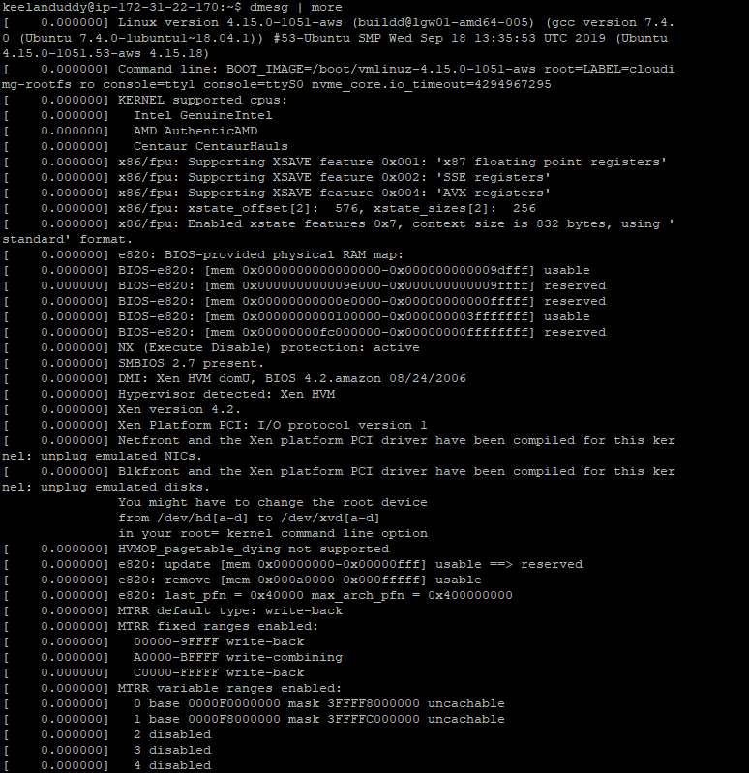

## Uptime:

It is used to find out how long the system is active (running). This command returns set of values that involve, the current time, and the amount of time system is in running state, number of users currently logged into, and the load time for the past 1, 5 and 15 minutes respectively.



## Whoami:

It displays the username of the current user when this command is invoked



## Who:

displays a list of users who are currently logged into the computer.

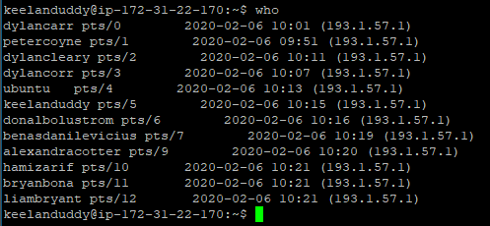

## Last:

is used to display the list of all the users logged in and out since the file /var/log/wtmp was created.

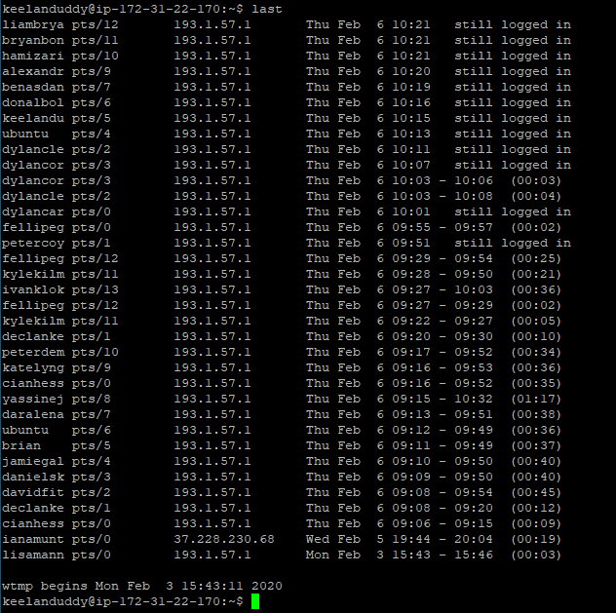

## Finger:

Can be used to look up specific users, an example would be @host to find the hosts user name.

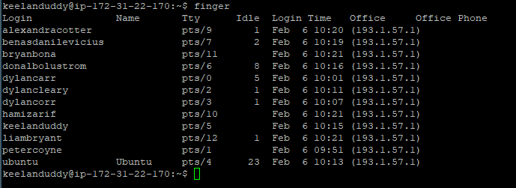

## W:

w command in Linux is used to show who is logged on and what they are doing.

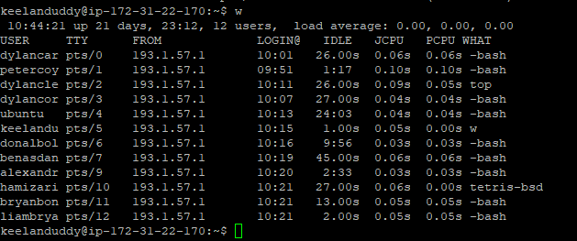

## Top:

displays processor activity of your Linux box and also displays tasks managed by kernel in real-time. It'll show processor and memory are being used and other information like running processes

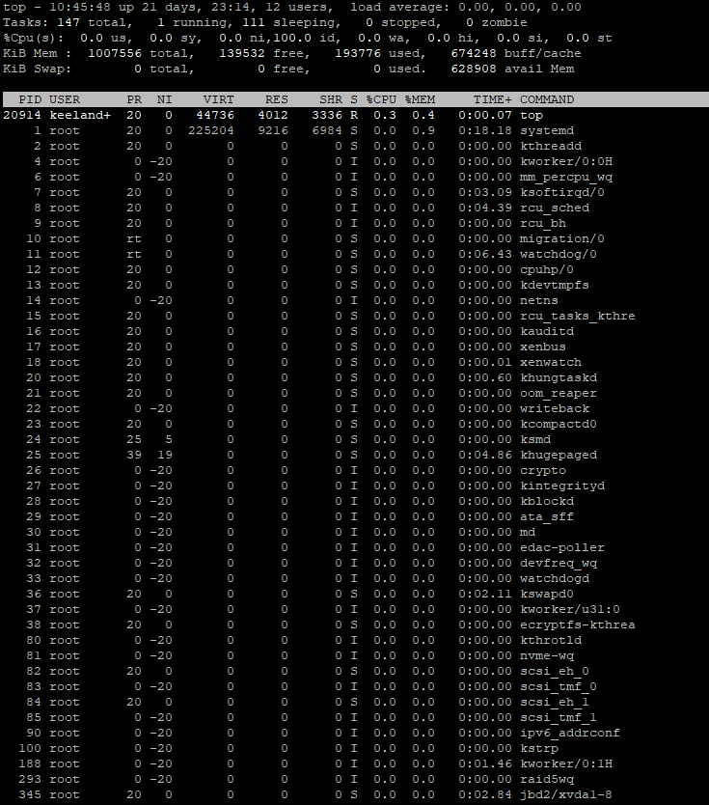

## ECHO $SHELL:

echo command in linux is used to display line of text/string that are passed as an argument . This is a built in command that is mostly used in shell scripts and batch files to output status text to the screen or a file.



## Man ls:

display the user manual of any command that we can run on the terminal. It provides a detailed view of the command

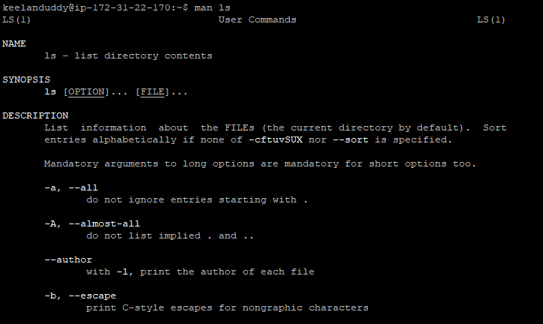

## Man who:

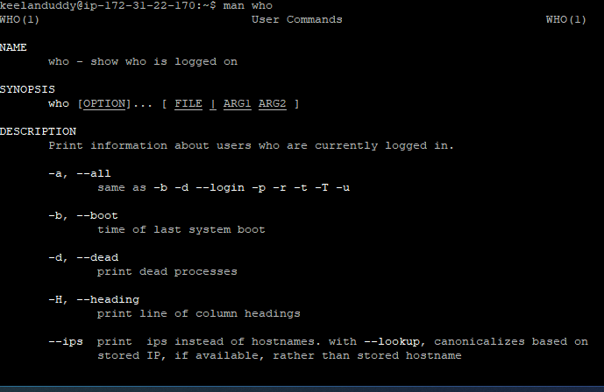display the user manual of any command that someone can run on their terminal. It provides a detailed view of their commands

Clear: (you said you didn’t need screenshot in the lab). Clear cleans up everything that was on screen.

## Cal 2000:

Brings up the dates and moths of the year 2000

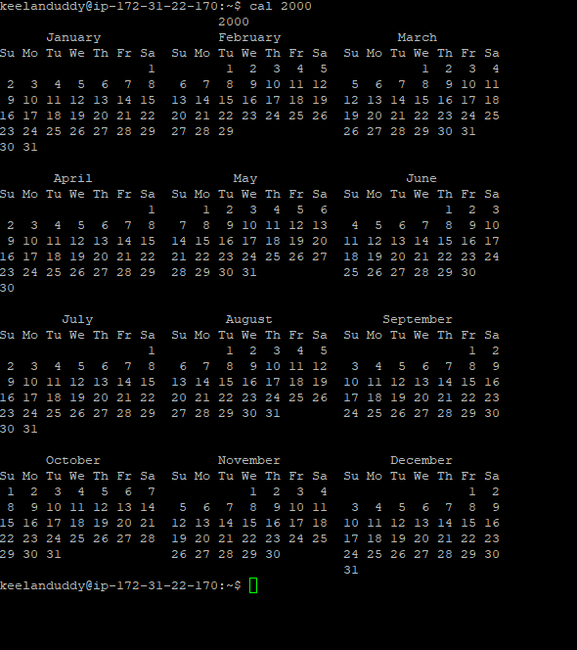

Cal 9 1752: the calendar is missing the dates of the 3rd to the 13th . brings up the specfic month of that year and it’s dates.

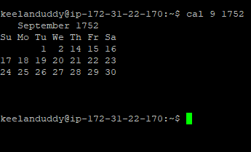

## Yes please:

yes command in linux is used to print a continuous output stream of given string.

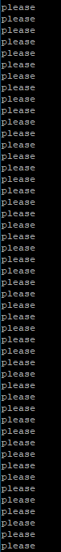

## Time sleep 5:

prints a summary of real-time, user CPU time and system CPU time spent by executing a command when it terminates.Shows the activity of the last 5 seconds

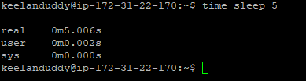

## Tetris-bsd:

Displays a playable game of tetris

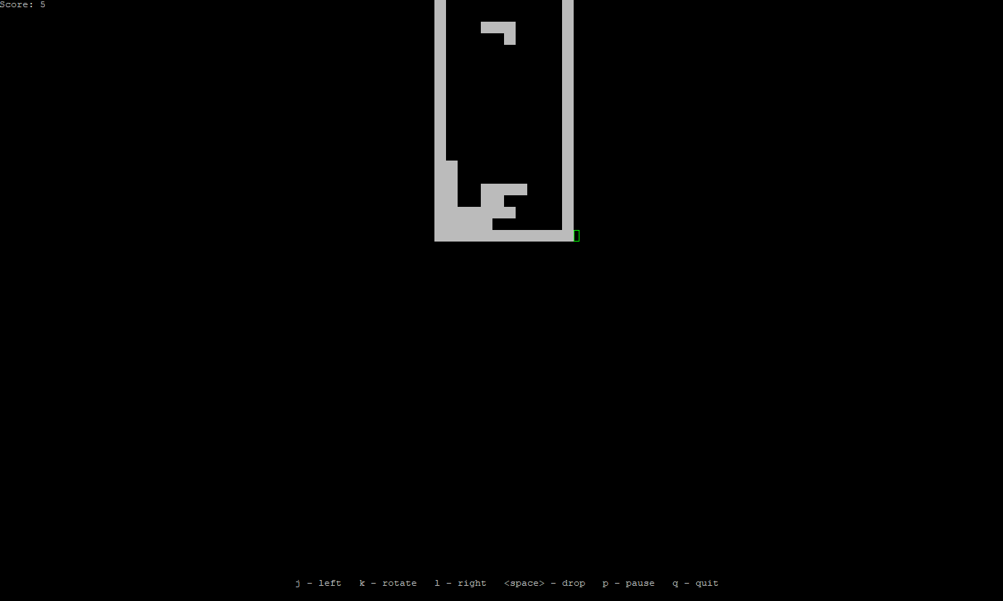

## History:

A history list of all the commands the user inputted

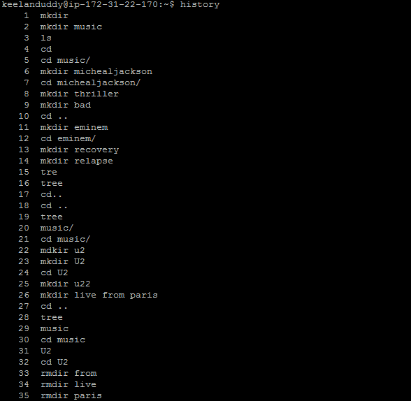

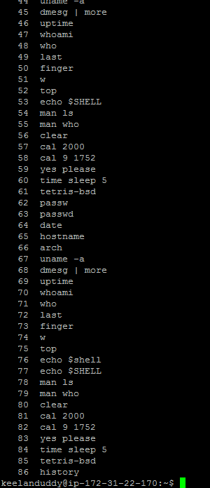

# Lab 5 linux vm & permissions:

## Virtual machine:

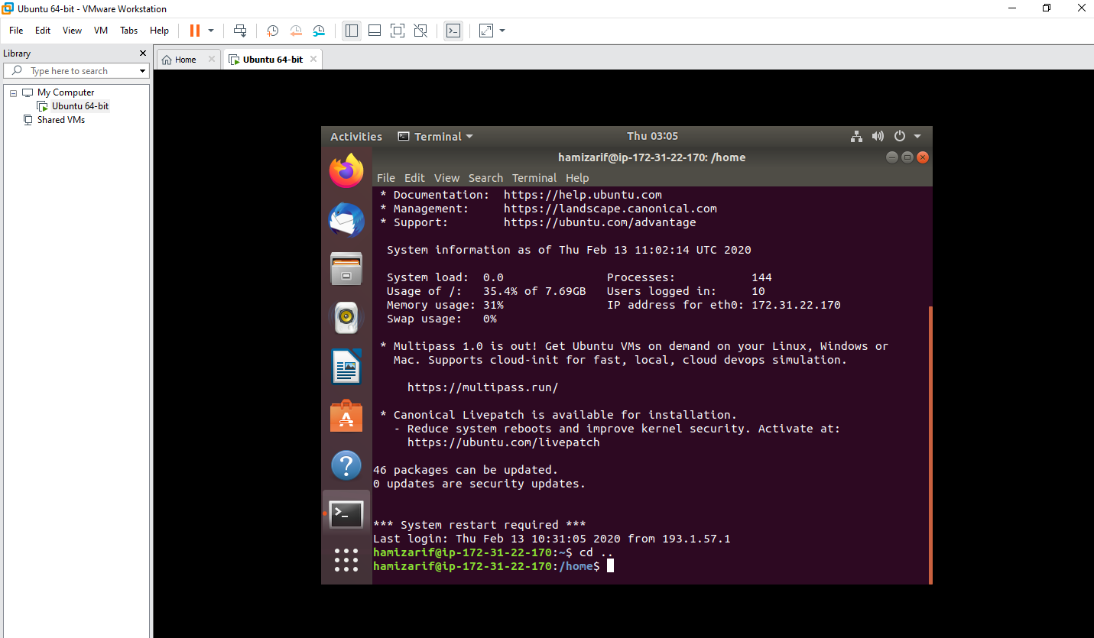

## Permissions:

